Thermodynamics

Thermodynamics is the branch of physics that has to do with heat and temperature and their relation to energy and work. The behavior of these quantities is governed by the four laws of thermodynamics, irrespective of the composition or specific properties of the material or system in question. The laws of thermodynamics are explained in terms of microscopic constituents by statistical mechanics.

# University of new hampshire

The University of New Hampshire (UNH) is a public research university in the University System of New Hampshire, in the United States. The university's Durham campus, comprising six colleges, is located in the Seacoast region of the state. A seventh college, the University of New Hampshire at Manchester, occupies the university's campus in Manchester, the state's largest city. The University of New Hampshire School of Law, known as the Franklin Pierce Law Center until 2010, is located in Concord, the state's capital.  
The University of New Hampshire was founded and incorporated in 1866, as a land grant college in Hanover in connection with Dartmouth College. In 1893, UNH moved to Durham.  
With over 15,000 students between its Durham, Manchester, and Concord campuses, UNH is the largest university in the state. UNH is one of only a few universities that is designated a land-, sea-, and space-grant institution. The university's current President is James W. Dean Jr., the 20th President of the University, who took over from Mark Huddleston on June 30, 2018. Their mascot is a wildcat and the university's colors are blue and white.

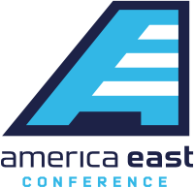



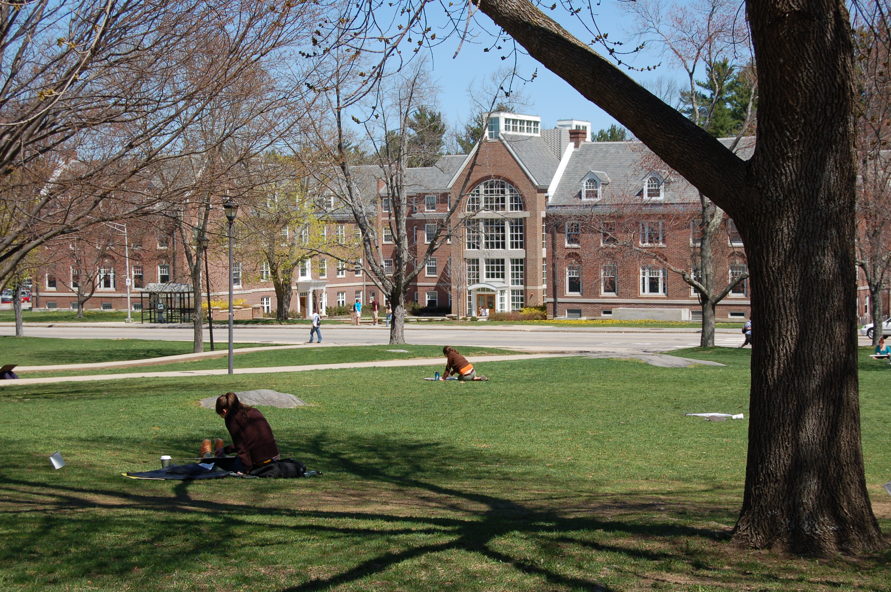

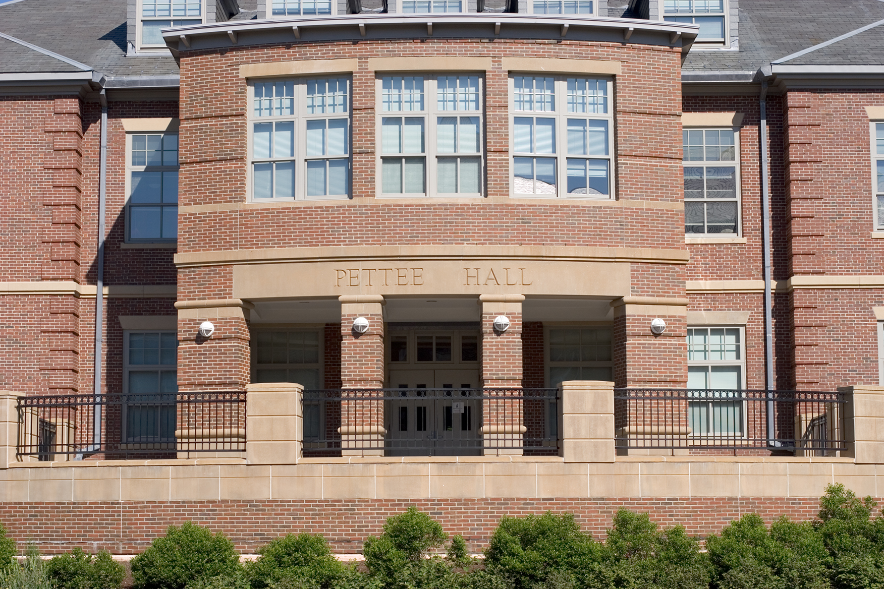

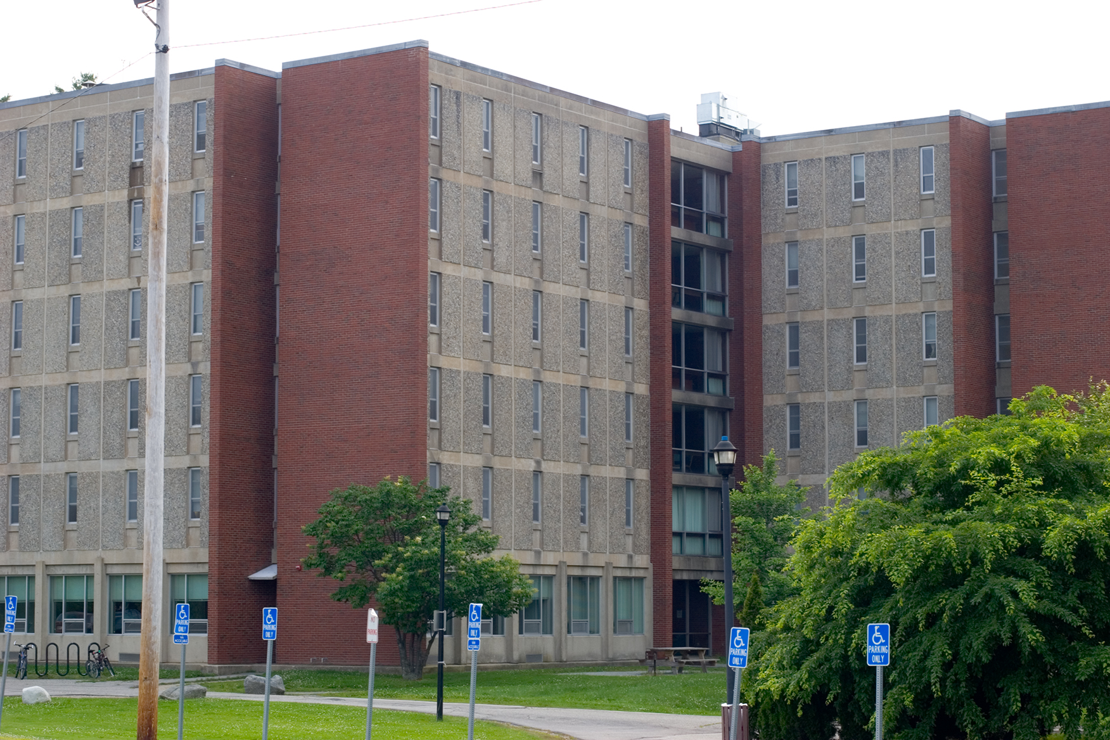





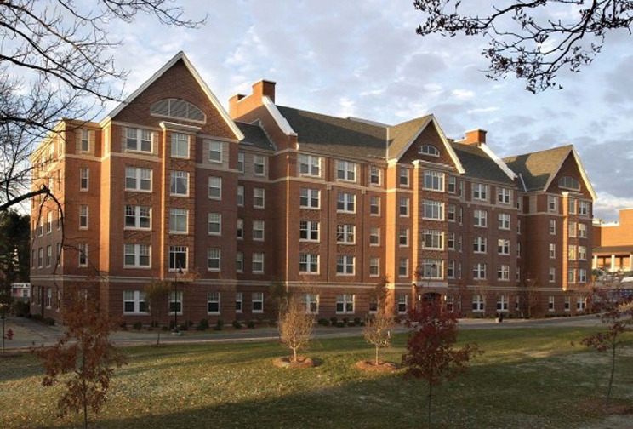

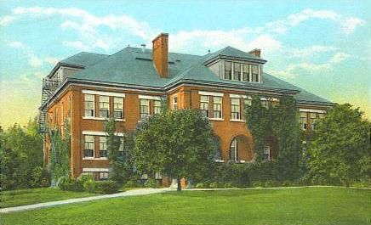



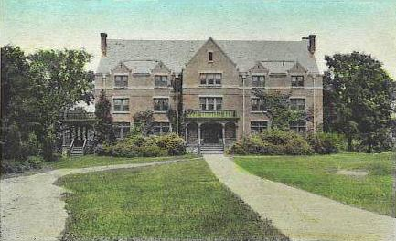





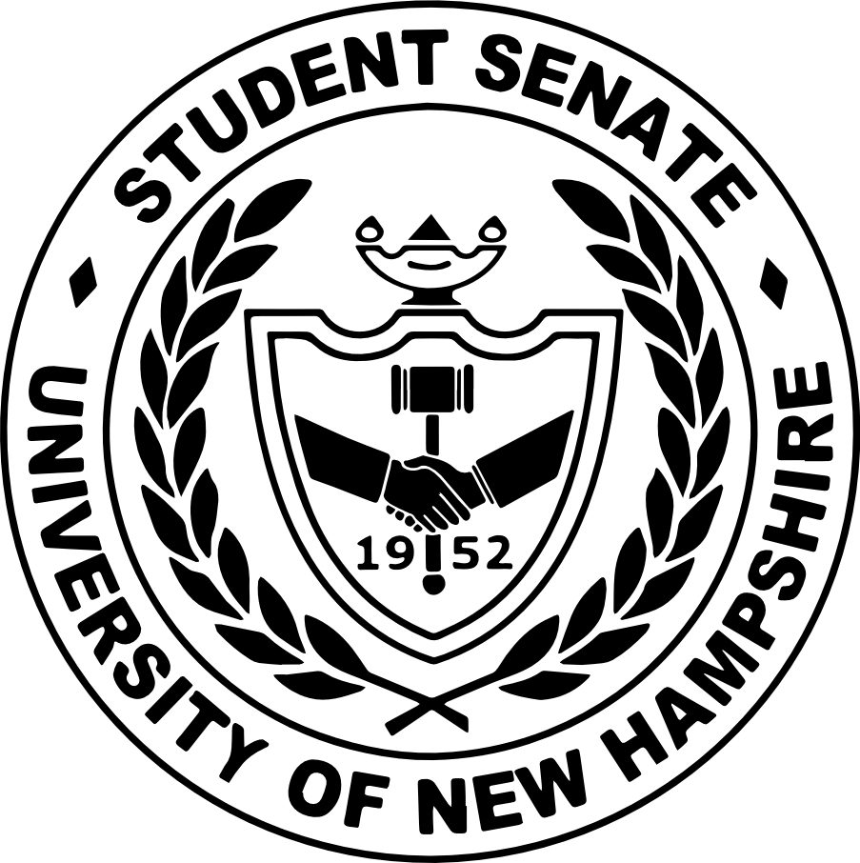

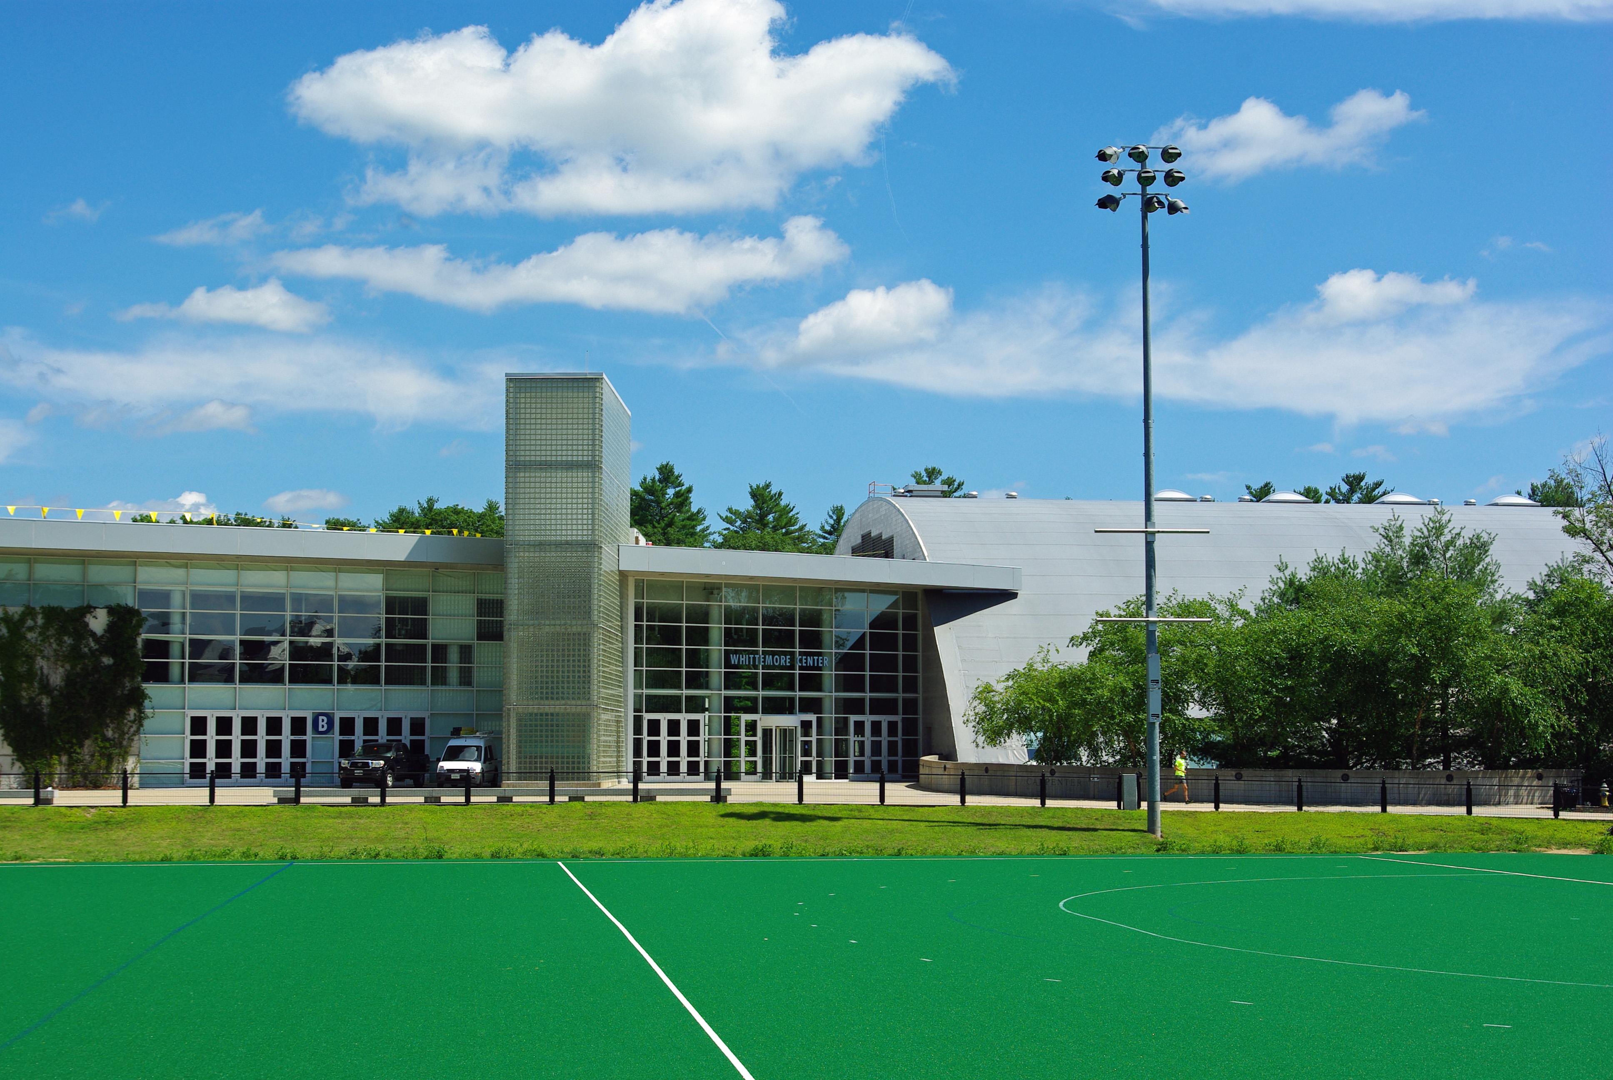



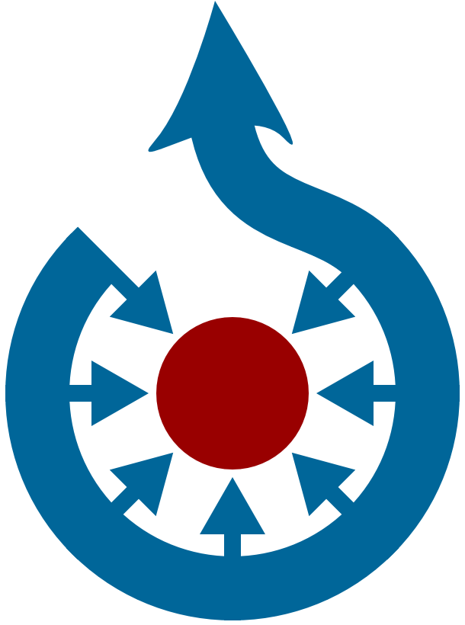







# Assembly language

An assembly (or assembler) language, often abbreviated asm, is any low-level programming language in which there is a very strong correspondence between the program's statements and the architecture's machine code instructions.Each assembly language is specific to a particular computer architecture and operating system. In contrast, most high-level programming languages are generally portable across multiple architectures but require interpreting or compiling. Assembly language may also be called symbolic machine code.Assembly language usually has one statement per machine instruction, but assembler directives, macros and symbolic labels of program and memory locations are often also supported.  
Assembly code is converted into executable machine code by a utility program referred to as an assembler. The conversion process is referred to as assembly, or assembling the source code.





